**Задание 1**.

wmic memorychip get banklabel, capacity, speed, manufacturer, Memorytype, PartNumber



Get-WmiObject -Class "Win32_PhysicalMemory"

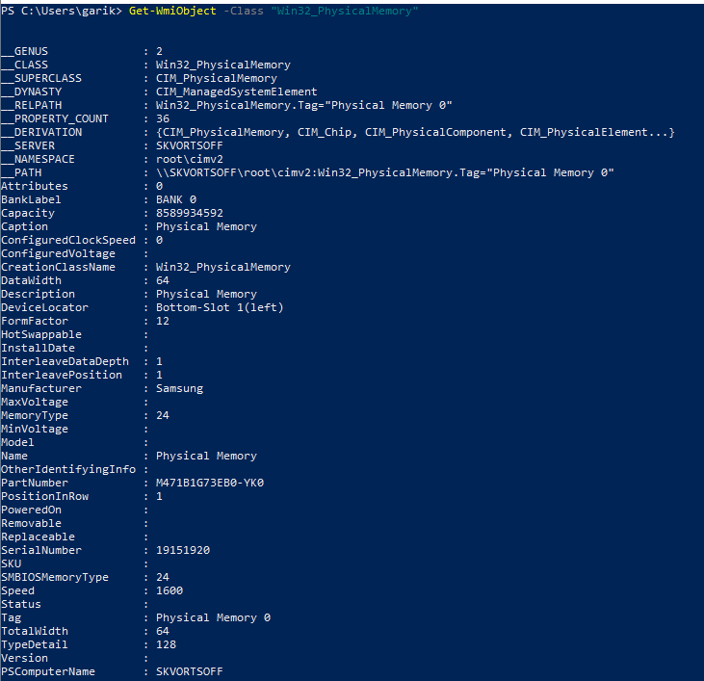

Windows + R , msinfo

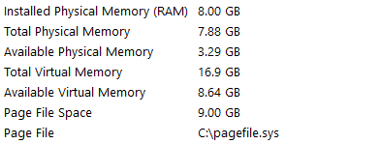

Systeminfo | findstr “Memory” “памят”

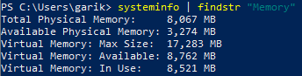

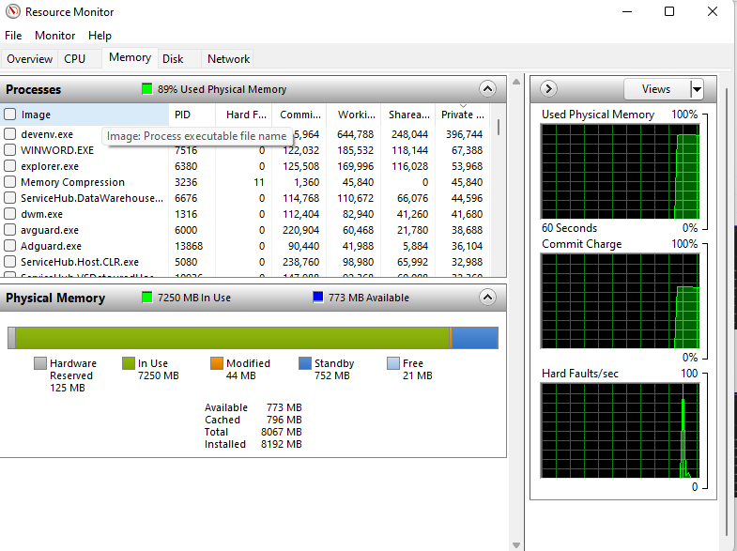

**Задание 2**



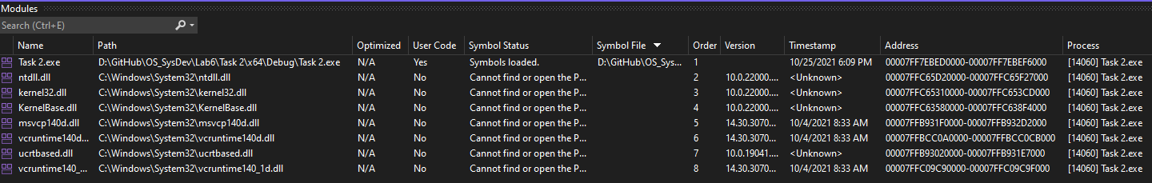



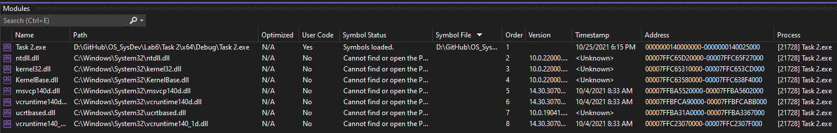

**Задание 6**

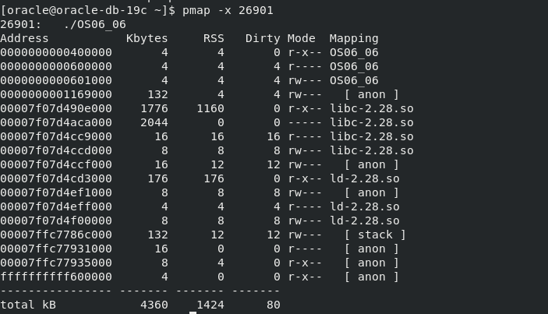

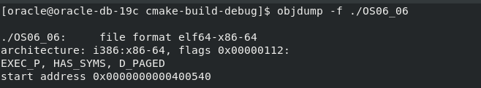

**Задание 7**

